10.34: As a point, the woman’s moment of inertia with respect to the disk axis is 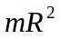, and so the total angular momentum is
